**Report Template:**

**CS205 C/ C++ Program Design Assignment 1**

**Name**: 罗森滋, **SID**: 3120001095

Part 1. Source Code

//requirement 1 case 1

#include<iostream>

int main(){

using namespace std;

int num1=0,num2=0;

cout<<"Please input two integers"<<endl;

cin>>num1>>num2;

cout<<"the multiply of them is:"<<num1*num2<<endl;

return 0;

}

//requirement 2

//This program can detect if the input is valid and then call attention to the user for inputing again

#include<iostream>

int main() {

using namespace std;

int num1 = 0, num2 = 0, judge = 1;//define variable

cout << "Please input one integer" << endl;

while (!(cin >> num1)) {//firstly judge whether the first num is valid

cin.clear();

cin.ignore();//clear the num input before

cout << "invalid input,please try again" << endl;

}

cout << "Now please input the other integer" << endl;

while (!(cin >> num2)) {//then judge the other integer

cin.clear();

cin.ignore();

cout << "invalid input,please try again" << endl;

}

cout << "the multiply of them is:" << num1 * num2 << endl;//multiply two integers

return 0;

}

//requirement 3

//solution :change the type of data num1 and num2,for example, change it form "int" to "long long "

int main(){

using namespace std;

long long num1=0,num2=0;

cout<<"Please input two integers"<<endl;

cin>>num1>>num2;

cout<<"the multiply of them is:"<<num1*num2<<endl;

return 0;

}

Part 2. Result & Verification

In this part, you should present the result of your program by listing the output of test cases and optionally add a screen-shot of the result.

Test case #1:

Input 2 3

Output 6

Screen-short for case #1:

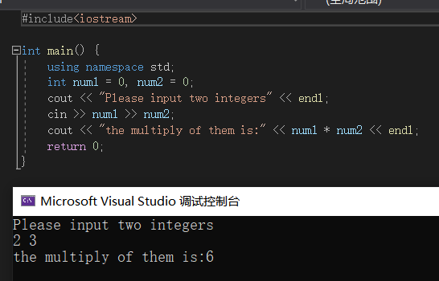

Test case #2:

Input a 2 3

Output wrong 6

Screen-short for case #2:

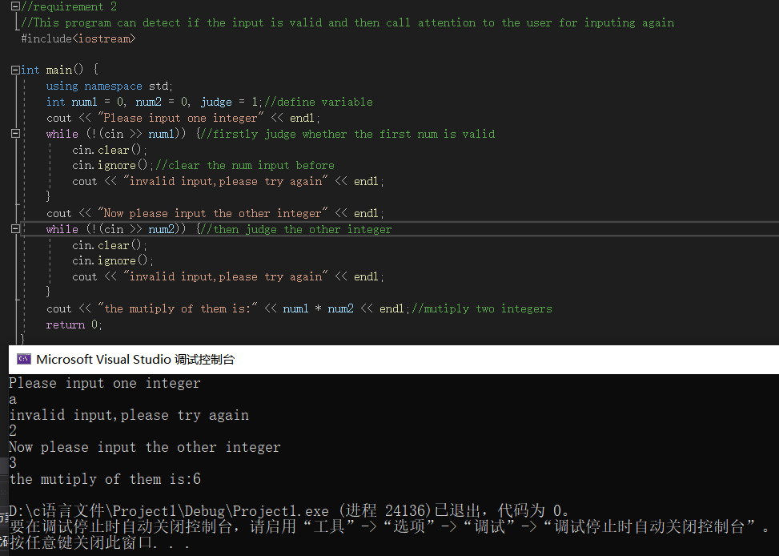

Test case #3:

Input 1234567890 1234567890

Output 1524157875019052100

Screen-short for case #3:

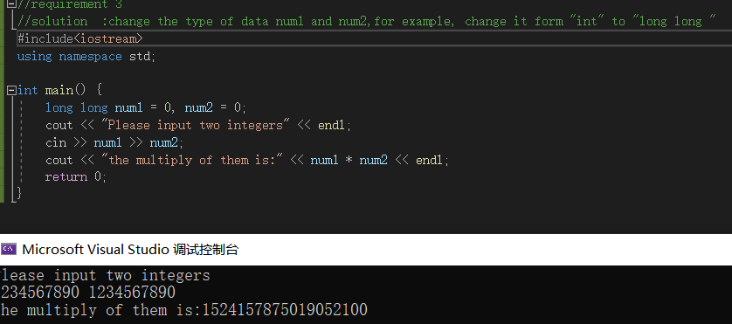

Part 3. Difficulties & Solutions, or others

1. In assignment two,I can’t find a way to clear both data(1 and 2) I’ve input,so at last,I have to input data separately and clear them separately.
2. In assignment three,I have a clear solution, which use array to solve the problem,in my mind,but without the knowledge of structure,I can’t code it.